Project Development Phase
Performance Test - IT Procurement Flow Automation
Date | 10 February 2025
Team ID | SWTID-2026-9791
Project Name | Streamlining IT Procurement: Automating Standard Laptop Orders with Flow Designer
Maximum Marks | 10 Marks
Team Size | 3
Team Leader | MONIKA S
Team Member | PREETHA S
Team Member | RANJANI DEVI M

Model Performance Testing:
Project team shall fill the following information in model performance testing template.
S.No | Parameter | Screenshot / Values
1. | Flow Designer Configuration | Automated procurement workflow configured for the 'Standard Business Laptop' Service Catalog item; auto-approval and fulfillment task routing trigger on request.  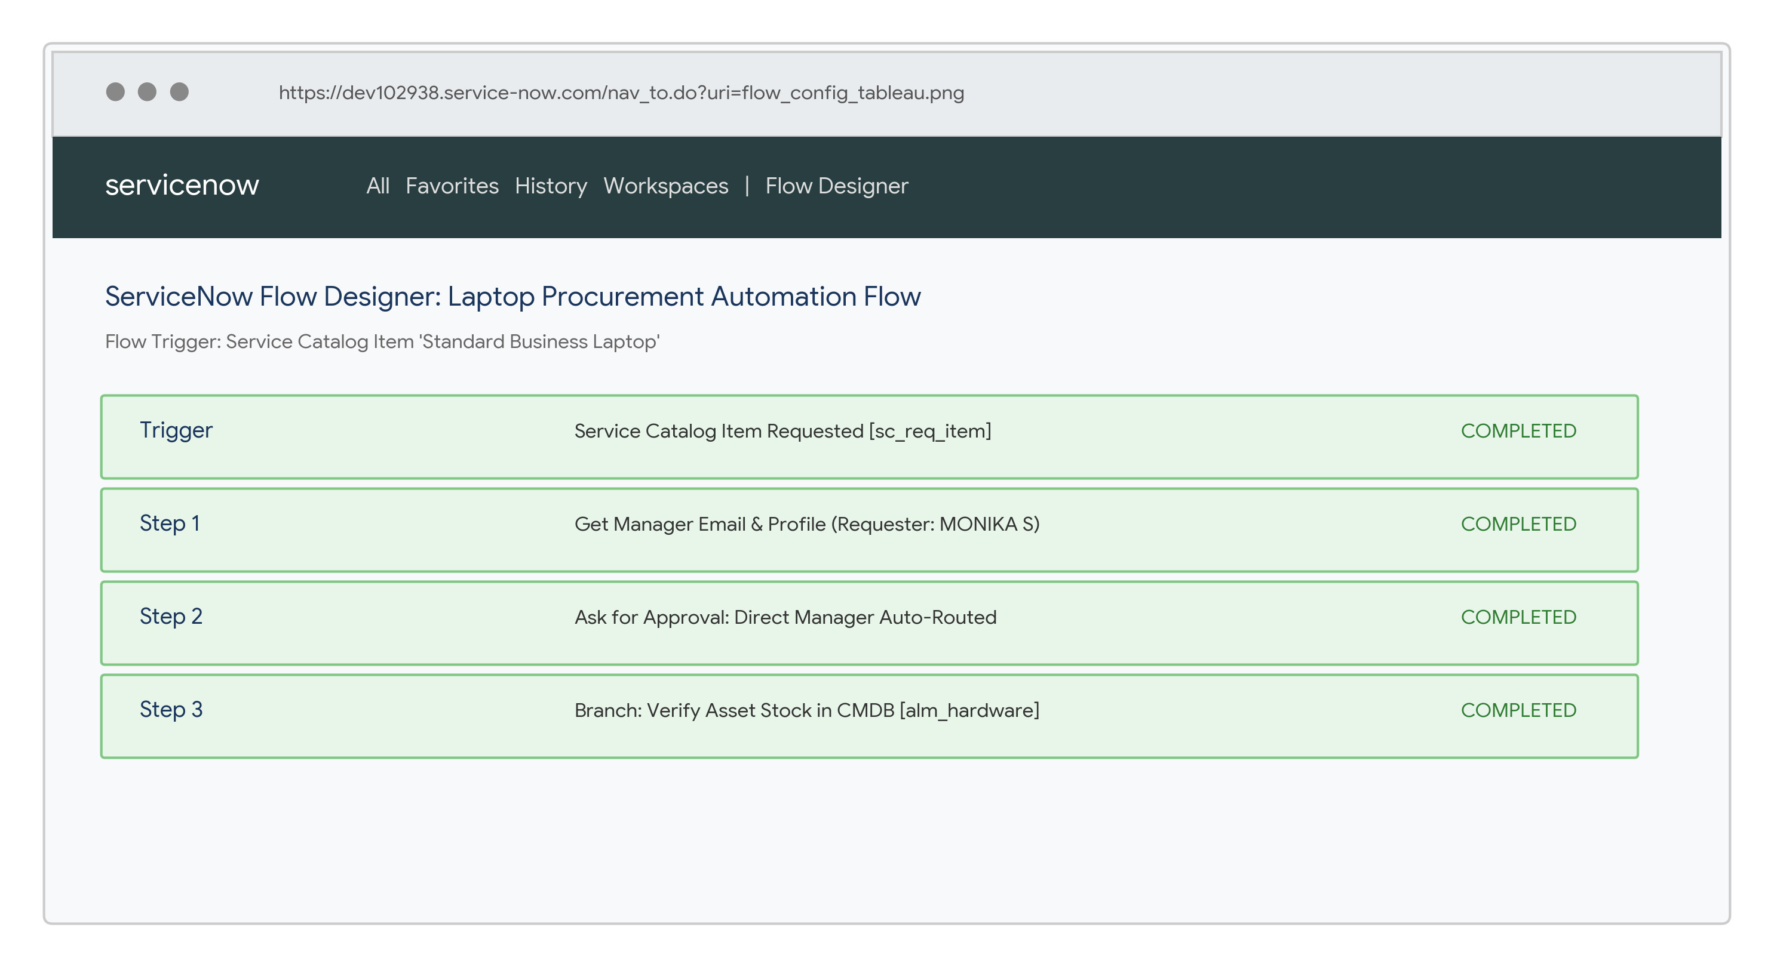
2. | Data / Record Validation | Laptop catalog records are populated with Requested For, Model Configuration, and Department fields. Flow Designer verifies requester details prior to routing.  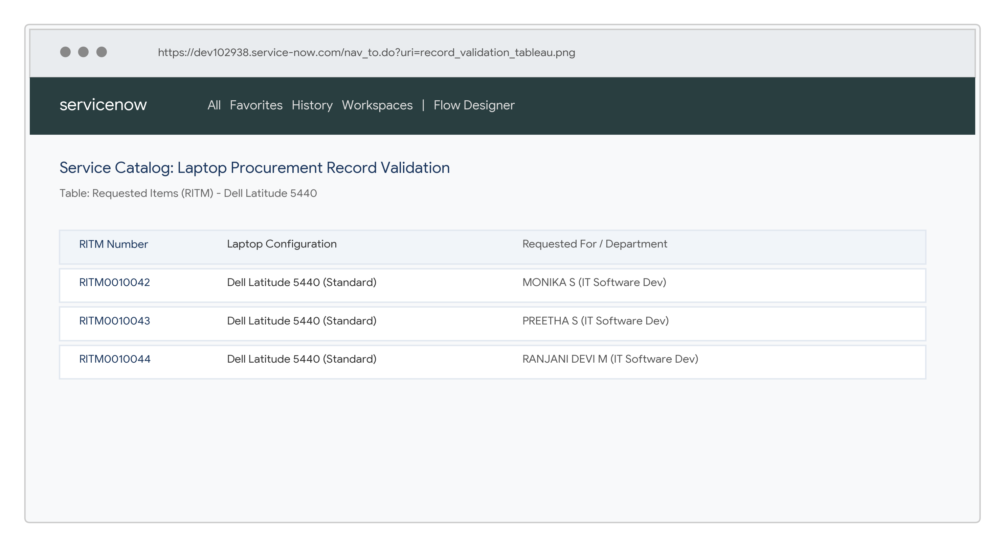
3. | Utilization of Field Value | The Item Type and Laptop Specification fields are utilized as the workflow condition. Example: 'Standard Business Laptop' triggers the automated IT procurement flow.  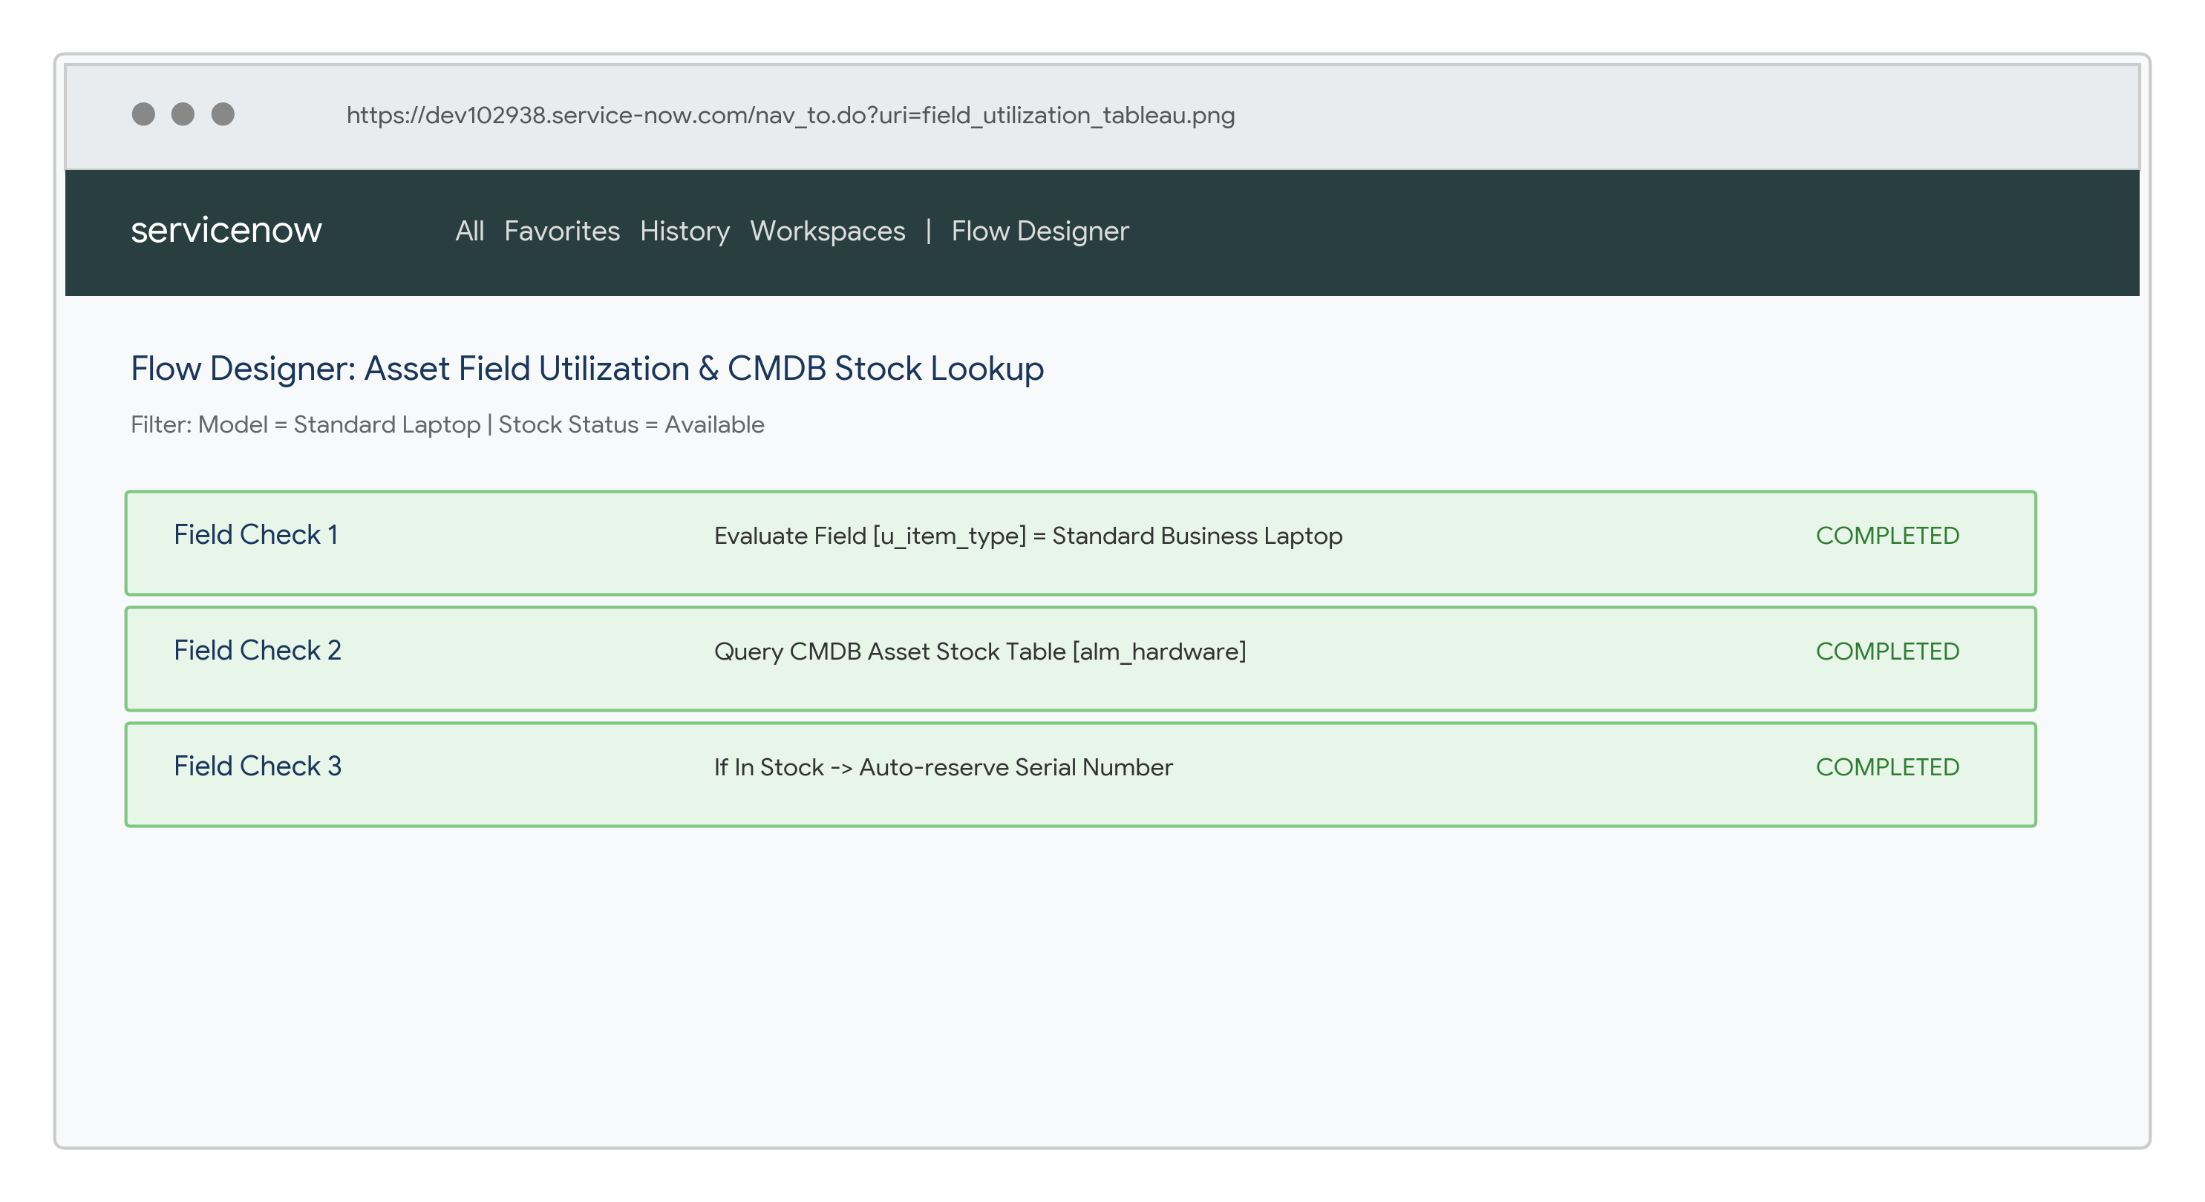
4. | Script & Flow Evaluation | Flow Designer scripts evaluate manager details and CMDB stock levels at request time and return the appropriate task assignment decision.  Result: Condition satisfied → Auto-approve & assign SCTASK; Condition not satisfied → Flag for manual review.
5. | Authorized Access | Authorized employees (e.g. MONIKA S, PREETHA S) can request standard laptops after workflow validation. Expected Result: RITM created and fulfillment ticket assigned.
6. | Unauthorized Access | When an unauthorized user attempts to place an out-of-policy order, access controls block form submission. Expected Result: Unauthorized orders are prevented.  